製作JSTL DB sql標籤的使用(1)
1. C:\apache-tomcat-7.0.42\webapps\ROOT\WEB-INF下建立lib資料夾
2. C:\apache-tomcat-7.0.42\webapps\ROOT\WEB-INF\lib資料夾內加入JSTL類別庫standard.jar , jstl.jar 及 資料庫類別庫 derby.jar , derbyclient.jar,derbynet.jar
3. C:\apache-tomcat-7.0.42\webapps\ROOT內新增 MyCreateTable.jsp 建立資料表

<%@ page import="java.io.*,java.util.*,java.sql.*"%>
<%@ page import="javax.servlet.http.*,javax.servlet.*" %>
<%@ taglib uri="http://java.sun.com/jsp/jstl/core" prefix="c"%>
<%@ taglib uri="http://java.sun.com/jsp/jstl/sql" prefix="sql"%>

<html>
<head>
<title>Create Operation</title>
</head>
<body>
<sql:setDataSource var="sample" driver="org.apache.derby.jdbc.ClientDriver"
url="jdbc:derby://localhost:1527/sample"
user="app" password="app"/>
<sql:update dataSource="${sample}" var="result">
create table Employees
(
id int not null,
age int not null,
firstname varchar (255),
lastname varchar (255)
)
</sql:update>
<c:out value="Finish"/>
</body>
</html>
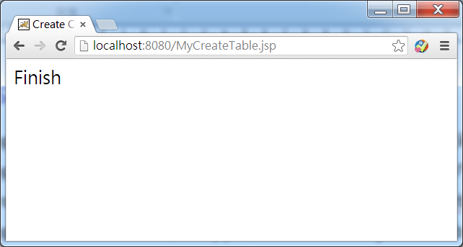
4. C:\apache-tomcat-7.0.42\webapps\ROOT內新增 MyDBInsert.jsp 新增資料列

<%@ page import="java.io.*,java.util.*,java.sql.*"%>
<%@ page import="javax.servlet.http.*,javax.servlet.*" %>
<%@ taglib uri="http://java.sun.com/jsp/jstl/core" prefix="c"%>
<%@ taglib uri="http://java.sun.com/jsp/jstl/sql" prefix="sql"%>
<html>
<head>
<title>JINSERT Operation</title>
</head>
<body>
<sql:setDataSource var="sample" driver="org.apache.derby.jdbc.ClientDriver"
url="jdbc:derby://localhost:1527/sample"
user="app" password="app"/>

<sql:update dataSource="${sample}" var="result">
INSERT INTO Employees VALUES (105, 3, 'Amy', 'Smith')
</sql:update>
<sql:query dataSource="${sample}" var="result">
SELECT * from Employees
</sql:query>
<table border="1" width="100%">
<tr>
<th>Emp ID</th>
<th>First Name</th>
<th>Last Name</th>
<th>Age</th>
</tr>
<c:forEach var="row" items="${result.rows}">
<tr>
<td><c:out value="${row.id}"/></td>
<td><c:out value="${row.firstname}"/></td>
<td><c:out value="${row.lastname}"/></td>
<td><c:out value="${row.age}"/></td>
</tr>
</c:forEach>
</table>
</body>
</html>
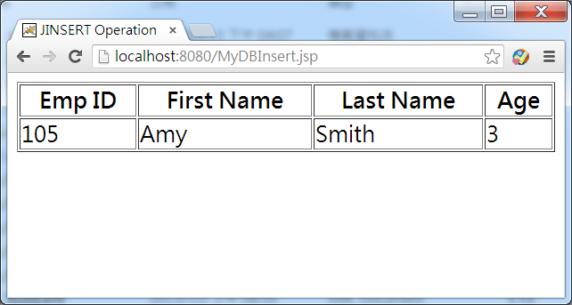
NetBeans製作JSTL DB sql標籤的使用(1)
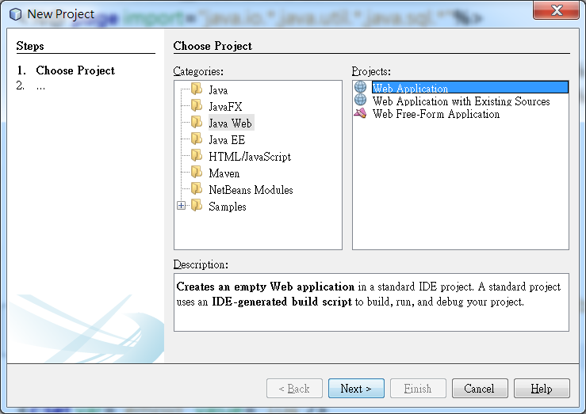
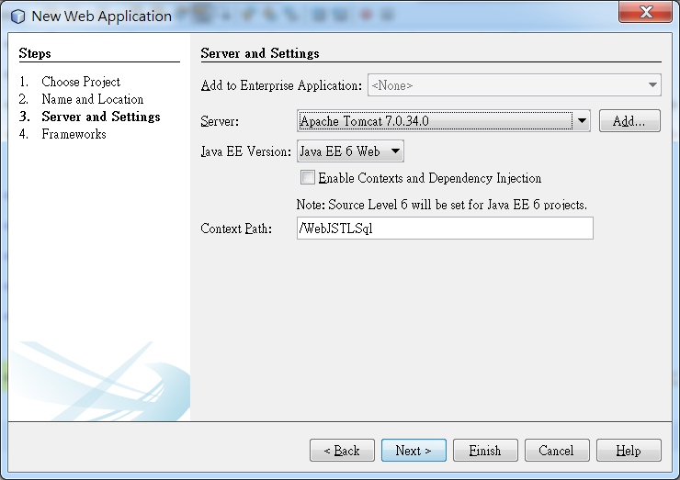
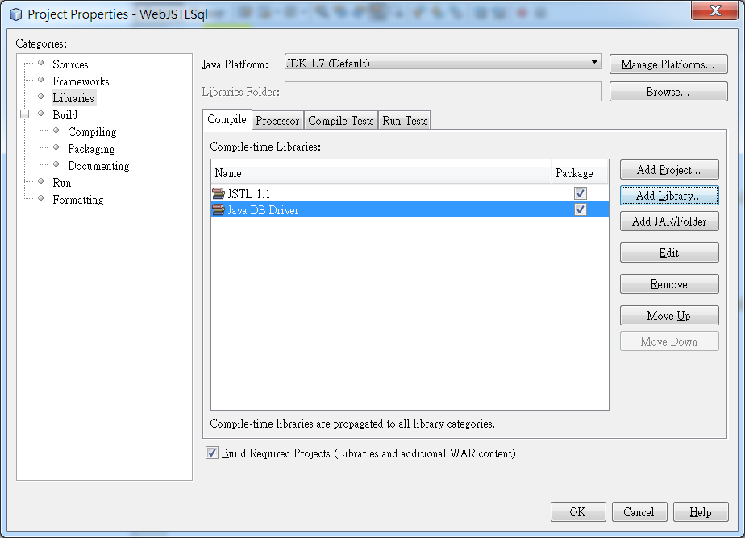
將MyCreateTable.jsp 及 MyDBInsert.jsp兩個檔案複製到 Web Pages下
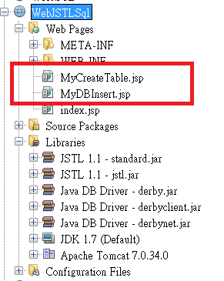
修改index.jsp 建立Employees表格輸入資料畫面並建立getUserData.jsp接收資料
<%@page contentType="text/html" pageEncoding="UTF-8"%>
<!DOCTYPE html>
<html>
<head>
<meta http-equiv="Content-Type" content="text/html; charset=UTF-8">
<title>JSP Page</title>
</head>
<body>
<h1>Hello World!</h1>
<form action="MDBInsert.jsp" method="post">
ID : <input type="text" name="uid" value="105"><br>
Age : <input type="text" name="age" value="20"><br>
FirstName : <input type="text" name="firstname" value="Mary"><br>
LastName : <input type="text" name="lastname" value="Anderson"><br>
<input type="submit" value="Send">
</form>
</body>
</html>
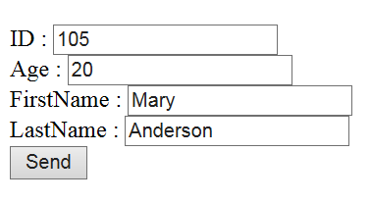
getUserData.jsp
<%@ page import="java.io.*,java.util.*,java.sql.*"%>
<%@ page import="javax.servlet.http.*,javax.servlet.*" %>
<%@ taglib uri="http://java.sun.com/jsp/jstl/core" prefix="c"%>
<%@ taglib uri="http://java.sun.com/jsp/jstl/sql" prefix="sql"%>
<html>
<head>
<title>GetUserData</title>
</head>
<body>
<c:set var="UID" value="${param['uid']}" />
<c:set var="FName" value="${param['firstname']}" />
<c:set var="LName" value="${param['lastname']}" />
<c:set var="Age" value="${param['age']}" />
<table border="1" width="100%">
<tr>
<th>Emp ID</th>
<th>First Name</th>
<th>Last Name</th>
<th>Age</th>
</tr><tr>
<td><c:out value="${UID}"/></td>
<td><c:out value="${FName}"/></td>
<td><c:out value="${LName}"/></td>
<td><c:out value="${Age}"/></td>
</tr></table> </body></html>
修改MyDBInsert.jsp如下:

<%@ page import="java.io.*,java.util.*,java.sql.*"%>
<%@ page import="javax.servlet.http.*,javax.servlet.*" %>
<%@ taglib uri="http://java.sun.com/jsp/jstl/core" prefix="c"%>
<%@ taglib uri="http://java.sun.com/jsp/jstl/sql" prefix="sql"%>

<html>
<head>
<title>JINSERT Operation</title>
</head>
<body>
<c:set var="UID" value="${param['uid']}" />
<c:set var="FName" value="${param['firstname']}" />
<c:set var="LName" value="${param['lastname']}" />
<c:set var="Age" value="${param['age']}" />
<sql:setDataSource var="sample" driver="org.apache.derby.jdbc.ClientDriver"
url="jdbc:derby://localhost:1527/sample"
user="app" password="app"/>
<sql:update dataSource="${sample}" var="result">
INSERT INTO Employees VALUES (${UID}, ${Age}, '${FName}', '${LName}')
</sql:update>
<sql:query dataSource="${sample}" var="result">
SELECT * from Employees
</sql:query>
<table border="1" width="100%">
<tr>
<th>Emp ID</th>
<th>First Name</th>
<th>Last Name</th>
<th>Age</th>
</tr>
<c:forEach var="row" items="${result.rows}">
<tr>
<td><c:out value="${row.id}"/></td>
<td><c:out value="${row.firstname}"/></td>
<td><c:out value="${row.lastname}"/></td>
<td><c:out value="${row.age}"/></td>
</tr>
</c:forEach>
</table>
</body>
</html>
